**BudgetApp**

1.Introduction:

This is a basic budget application. You add expenses and it calculates a sum. There are fixed expenses, which are supposed to be added by the app at the specified time every month (doesnt really do that). You can add Categories as well (for example Food or Transport).

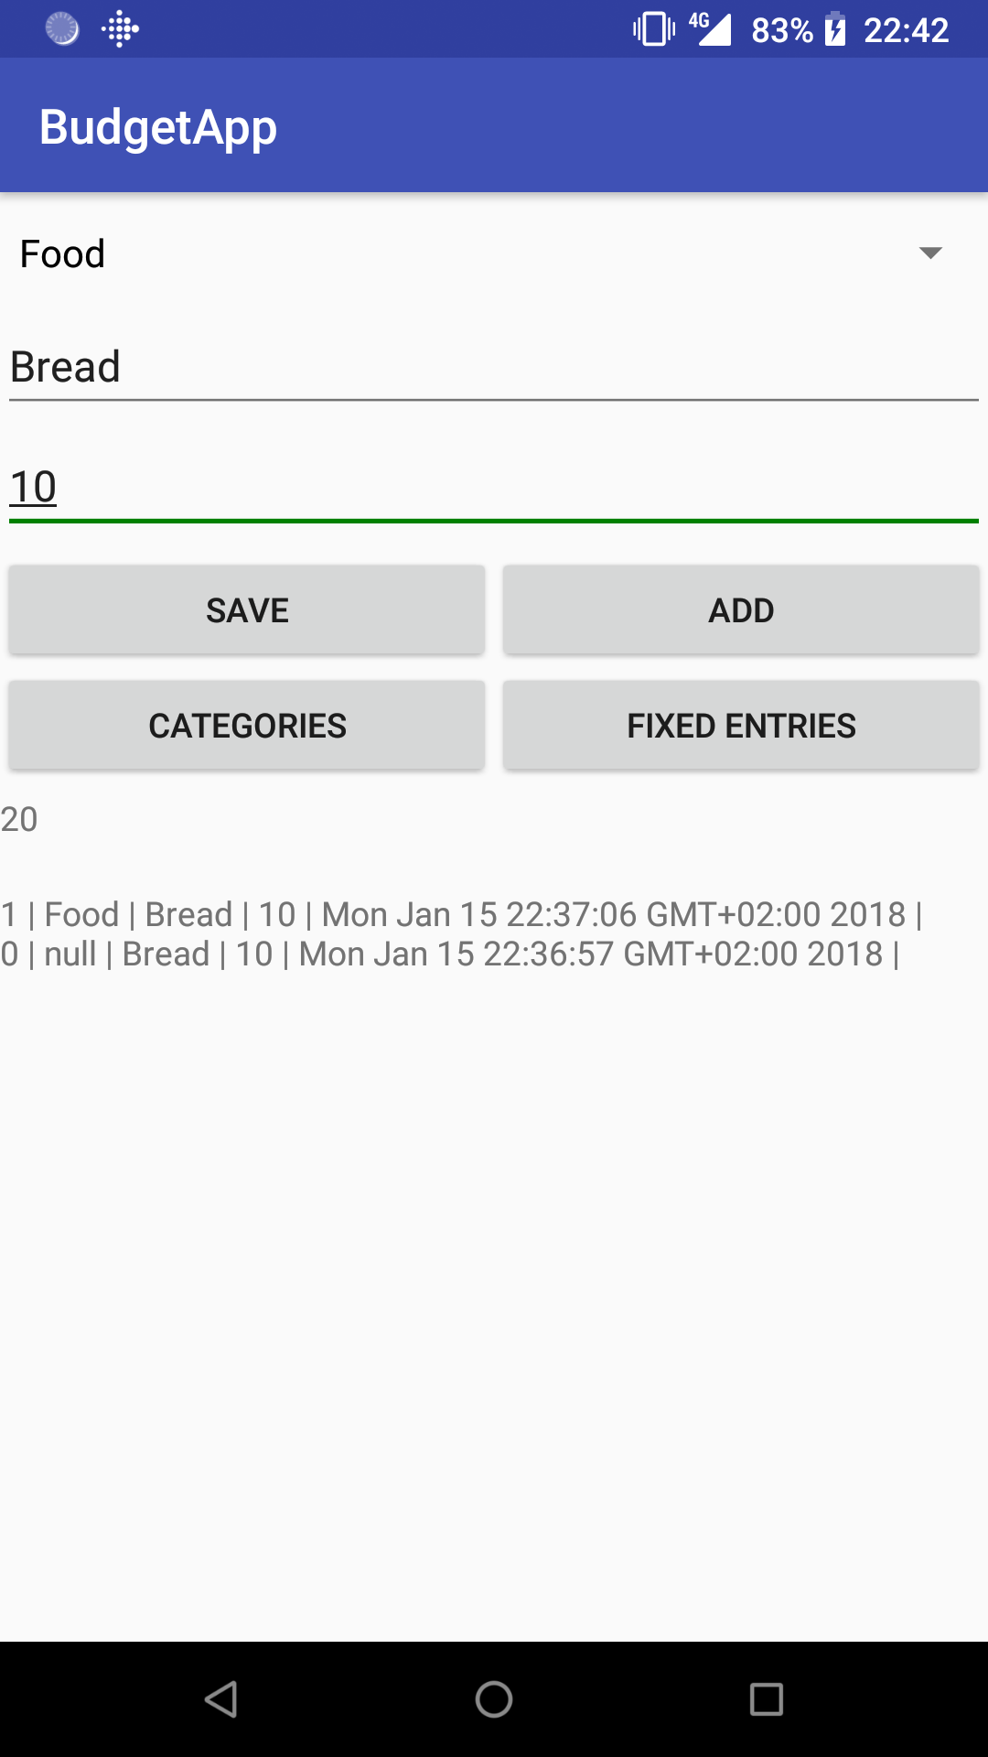2.Use Cases:

-This is the main activity. The category is selected from a list of previously added categories via a Spinner.

If no category is selected null is written in the entry.

First text box is for description, and the second one is for price(cost).

In this case Food is the category, bread is a specific description and 10 is the cost.

Time is added automatically.

After categories are added in the Categories activity, the ‘Save’ button must be pressed in order to be able to find it in the Spinner.

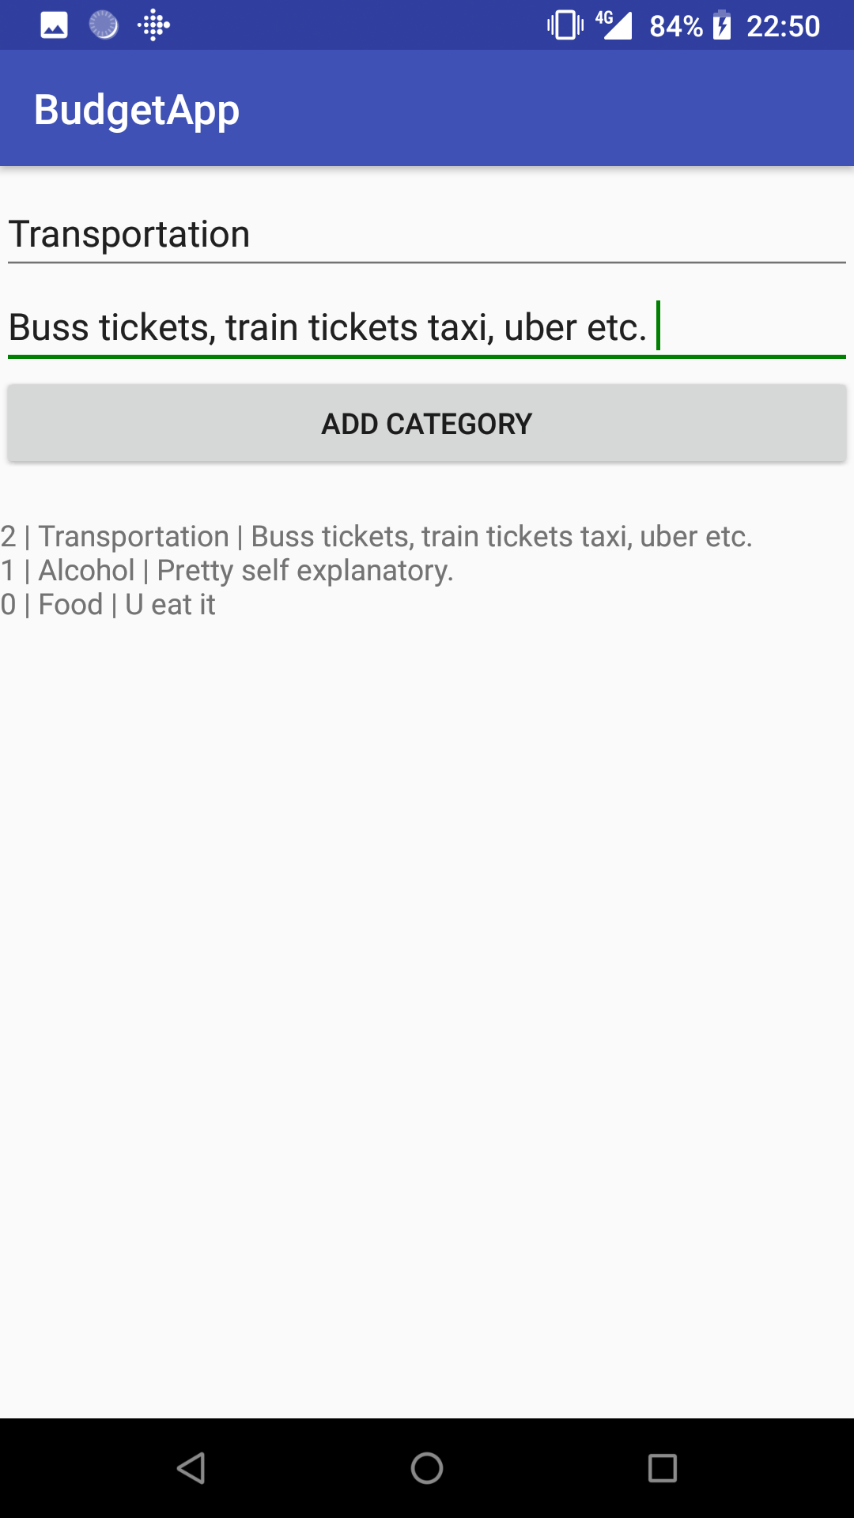

-This is the Category activity. First textbox is for name of category; second one is for description. Categories saved here can be found in the previous activity in the Spinner.

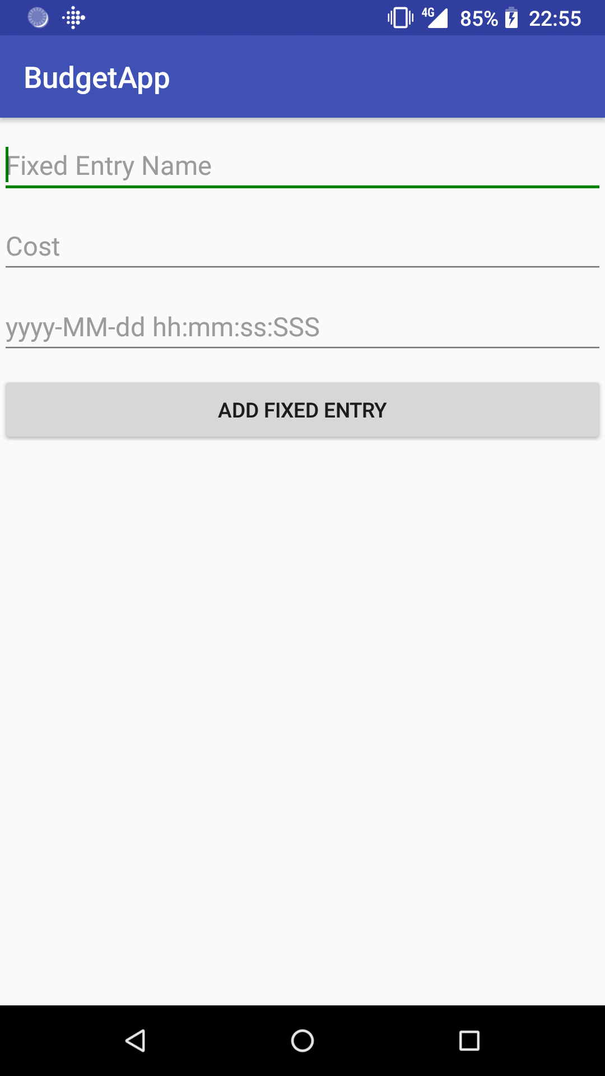

-This is the Fixed Entry Category. Unfortunately this on does not function properly, but its purpose was supposed to be to add an entry that adds itself to the total sum at the specified time; or repeatedly after a certain time interval. All it does at this time is store the information in a database.

3.Design & Classes:

-The Classes I implemented are:

* MyApplication – its only purpose is to initialize the database implemented with the Realm plugin.
* MyActivity - initializez main_layout, reads and saves data, via the savaData, readData functions.
* Fixed – similar to MyActivity, but specifically for fixed entries; uses different database table.
* CategoryList – similar to MyActivity, but specifically for Categories; uses third(final) table.
* Category – database model for Category entries;
* DynamicEntry – database model for quick added entries;
* FixedEntry – database model for repetitive entries.

4.Implementing Details:

-Most of this app is very dependent on its database. And the database was implemented with the Realm plugin (incredibly easy to use). No special algorithms were used.

5.Missing functions & Further Improvements:

-There are quite a lot of missing functions: removing entries, clearing database, making the fixed entries work.

-Further Improvements: inserting entries în a more scripted way (via SMS from bank, for transaction alert), showing the results în a catchier way.

Satmarean Dan Sergiu

Computer Science 2nd year, Group: 30423